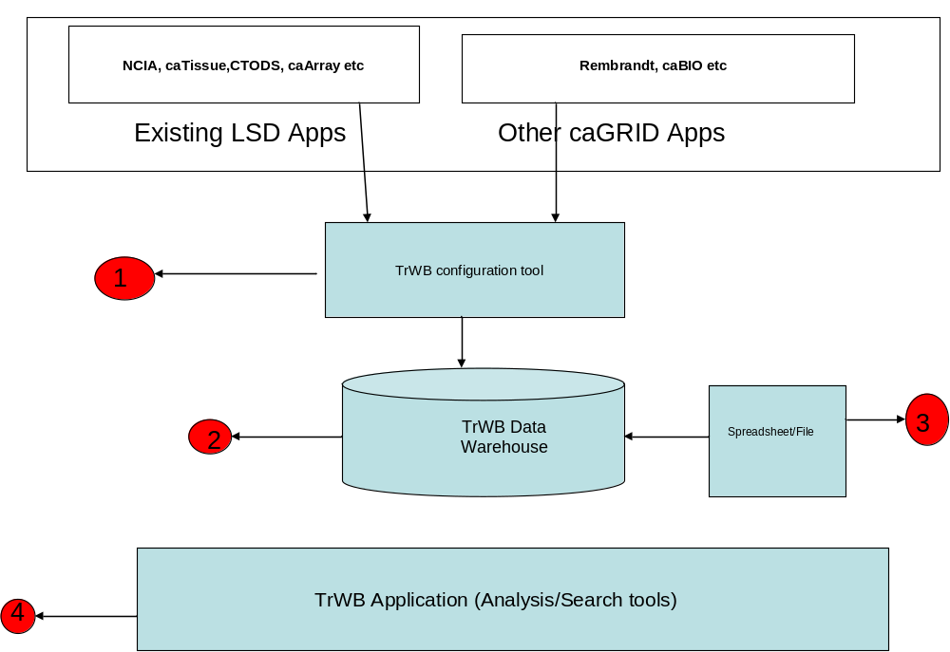

Details of the 4 different items above are given below.

- TrWB configuration tool: This tool allows users to select elements from existing models. These models can be any of the existing LSD applications or other caGrid models.

Input : various available models
Output: Add meta data to the Data warehouse

- TrWB Data Warehouse:A metadata driven, data warehouse which will hold all relevant data from all applications or other external sources.

- Flat File/Spread sheet loader: This will let the users load data that is not part of any existing model.

- Analysis/Visualization tool: This tool allows users to do analysis (searching, higher order analysis, heatmap viewer etc) on the data from the data warehouse. This can be similar to what we have for existing prototype (have their own instances)

There are several questions that should be addressed including

- Who will be the users of TrWB configuration tool?
- How will the data warehouse (meta data driven) looks like?
- How are we going to populate data warehouse (data)
- Is the Visualization tool going to customized for specific individual needs?

Use Case # 1

Source Model/Data
- Image from NCIA (Vasari)
- Clinical from CTODS for Rembrandt (Need to move Rembrandt clinical to CTODS)
- Expr or CopyNumber data from Rembrandt Services (from Grid)
Analysis
- Image search
- Pull a representative image from NCIA
- KM plot

Use Case # 2

Mutation Analysis
- Mutation from Cancer Genome WorkBench
- CopyNumber data from Rembrandt Services (from Grid)
- Tissue annotation from caTissue
Analysis
- Integrated heatmap

